Word Wizard

HELP US TEST THE BATTERY
LIFE OF OUR NON-VERBAL COMMUNICATION DEVICE!
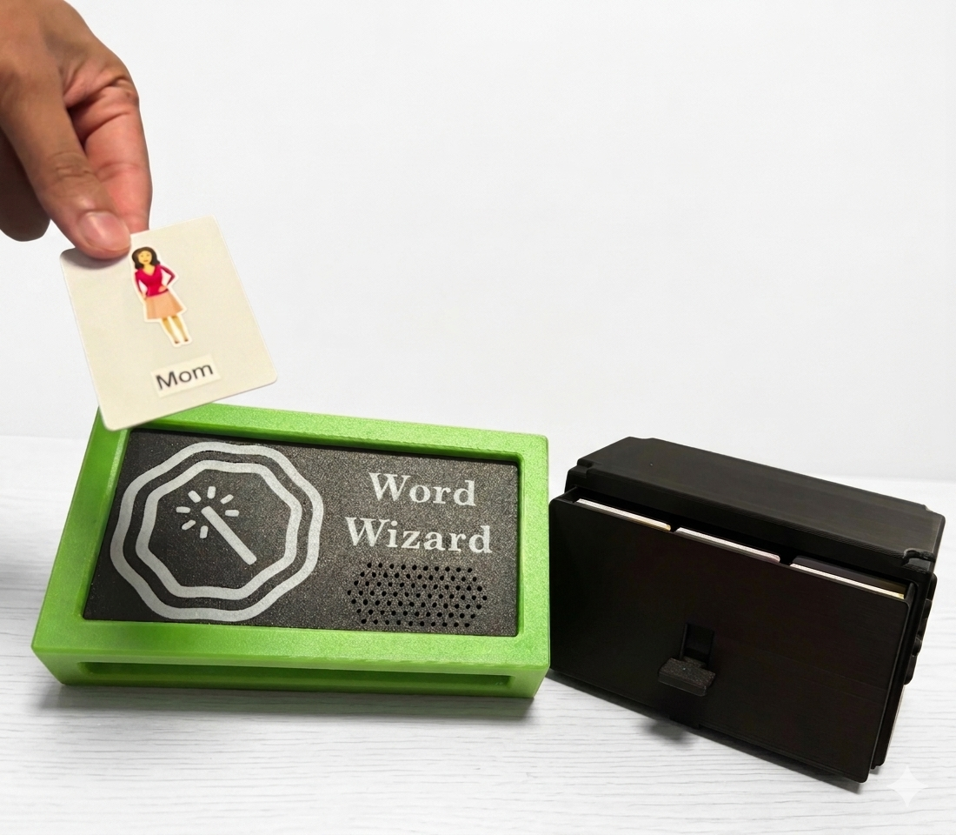

Tap a card to
hear it speak!
(If nothing happens, please
email l-frazer@onu.edu
to let us know the
battery died)

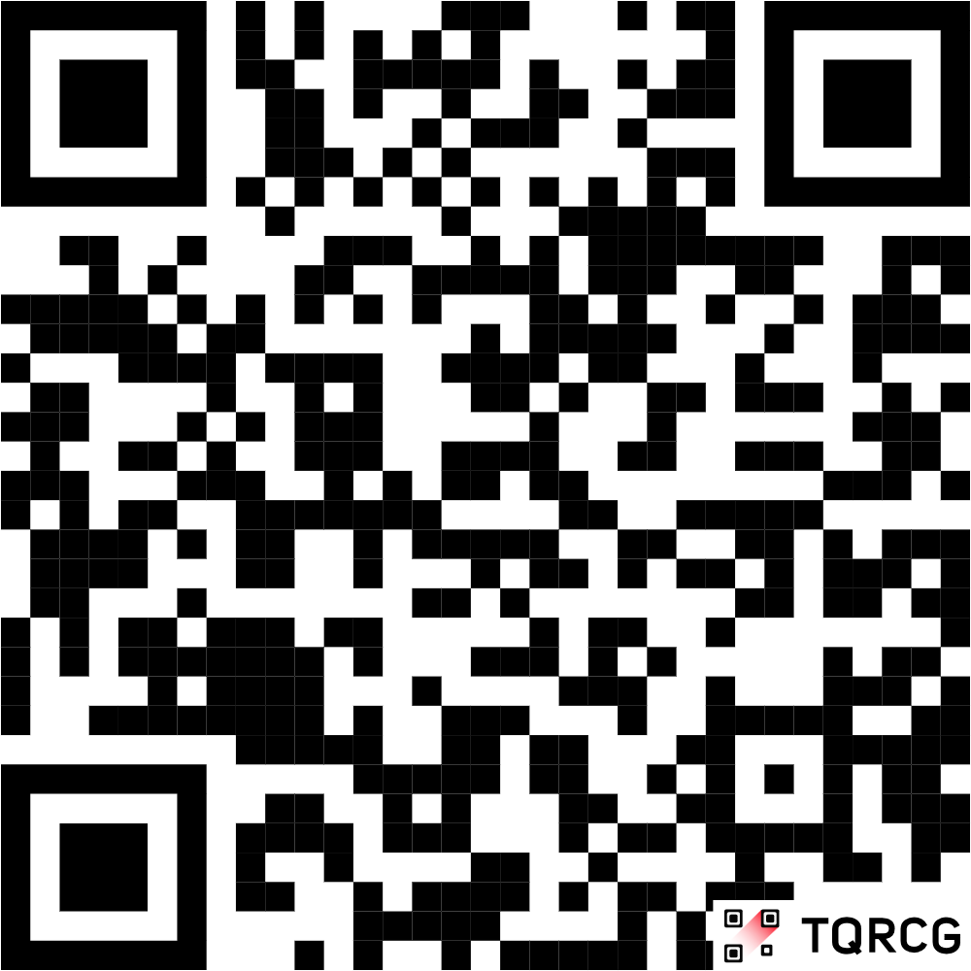
SCAN HERE
to learn more
about our
project!

